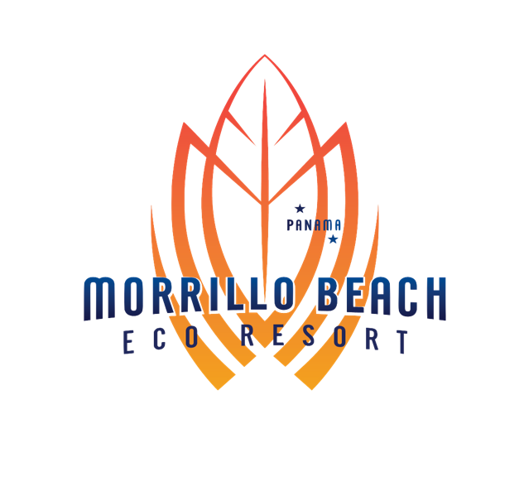

Packing List
One of the many great things about Panama is the warm climate, and the warm water. The sun is always strong here with UV ratings regularly high to extreme so sun protection is something to constantly be aware of to avoid a painful burn. Long sleeves and pants are always recommended for sun and bug protection. We want your experience here to be amazing so we have created this list to help you be as prepared as possible:
**Please Remember your reusable water bottle to avoid plastic waste**
Clothing
- Lightweight long sleeve shirt and pants for sun and bug protection
- Shorts and short sleeve shirts (both quick dry and soft cotton)
- Bathing suits
- Rash guard and tights for sun protection when surfing or snorkeling
- When in the city, it is casual but customary for Men to wear long pants, collared shirts, and shoes rather than sandals. Women typically wear skirts, dresses, and blouses. Jeans are OK too. Not everyone follows these rules but you might find that you are more socially comfortable if you follow the custom.
- Public transportation ie; busses, can be really cold so a light sweater is recommended
- The more obvious: underwear, socks, t-shirts,
- Women find a sarong is really useful
Gear
- Sunscreen, lotion, lip balm, aloe gel (for sunburn),
- Bug repellant
- Camera extra battery if necessary
- A waterproof bag for your phone and/or camera and valuables for use while hiking, on the beach, or on a boat
- Small backpack for use when going on day excursions. A Camelbak type pack for carrying water is really useful.
- Headlamp & batteries (maybe an extra as well because we often lose power here)
- Rain Gear is a good idea when out fishing or hiking at higher altitudes otherwise, its best just to wear quick-drying clothes and dry out when the rain stops because it is warm when it rains here.
- Travel umbrella for rain and sun protection
- Hat full brim hat for sun protection especially for being on the boat or a ball cap at least
- Sun protection for the neck if out hiking or on a boat all day
- Good book for reading
- Toothbrush, dental floss, toothpaste,
- Hair brush, hair ties
- Sunglasses and an extra pair
- Spanish Phrasebook to help communicate
- Reusable water bottle to avoid plastic waste
- High Quality Binoculars
- Passport and Drivers License
- Guidebook for what you enjoy looking at and for kids to learn: birds, mammals, butterflies etc.
- Collapsible fishing pole to take advantage of the great fishing in the estuary and also the rocks along the shore
- Kids really like to wear goggles when swimming in the estuary and the surf
- Travel first-aid kit is always nice to have with bandages, tape, Benadryl, antiseptic, painkillers, gauze, sterile dressings, tweezers, scissors, thermometer, antihistamines, sunburn treatment, insect repellant, insect bite treatment, medications for pre-existing conditions, condoms, rubber gloves, anti-diarrhea meds, indigestion/nausea meds like Pepto-Bismol, allergy medications, etc.
Footwear
- Sandals: flip flops for ease but if you want to go for a walk in sandals, it is recommended to wear a Chaco or Keen type sandal for better support and comfort
- Shoes: running/tennis shoes work well here and can be used on waterfall hikes if you don’t have good solid sandals like a Chaco or Keen
- Shoes or nice sandals for the city
Some Fun Extras
- Do you have a cool sticker to trade with us? It just might find a home on our kegerator at the bar
- Ryan collects beer glasses so if you have a pint glass you wish to bring; we will give you a free beer in it.
- Bring a USB with a good amount of storage if you want us to share adventure photos with you.
Finally, a great attitude to experience a new country, a new culture, new food, and some great adventure! We are SUPER excited to see and meet you and if you have any questions or concerns at all, please let us know. We want you to have an amazing trip!

